Thanom Chapakdee

**The Artists’ Front of Thailand**

The Artists’ Front of Thailand (AFT) formed in 1974, immediately following the violent political events of October 1973. The group came together for the purpose of mapping contemporary art and its manifestations, and also to shed light on the cultural value of the term, “Art for Life, Art for People” (Silapa phua Chiwit, Silapa phua Prachachon). In the 1970s, many cultural and artists’ groups rose up to take part in the democratic sphere. This response brought about a formal transition towards Socialist Realism, which integrated Marxist and Maoist ideology. At the same time, the Communist Party of Thailand (CPT) movement was expanding in both urban and rural areas in Thailand. Faced with the possibility of new freedoms and sharing a hunger for change, the Artists’ Front of Thailand successfully created art that reflected their manner of thinking and facilitated the dispersal of their ideas. In their art, the artists deal with subjects such as poverty, nationalism, racism, anti-capitalism and imperialism, while exhibiting a cynical attitude towards modernity. This was balanced by the figurative nature of their works, a style long ignored during the heyday of abstract art. While the Artists’ Front of Thailand movement lasted only two years, it left a significant legacy through its credo: “Art for life,” as well as its aesthetics.

The AFT emerged during a turbulent time in Thailand when many students who participated in the 1973 uprising died for the democratic cause. The artists’ group promoted the idea of “Art for Life, Art for People” to counter the notion of ‘Art for Art sake.’ The group’s manifesto, which was critical of issues of poverty, consumerism, imperialism and the impacts of totalitarianism, was published in 1975.

The Artists Front of Thailand movement was influenced by the Socialist Realist ideas that appeared in Jitr Phumisak’s book *Art for Life, Art for the People*, first published in 1957 and subsequently discovered by students in the Thammasat University library and cheaply reprinted in 1972,along with his essays on art and culture. Many books about Socialism were also translated and published during this period, including Mao Zedong’s seminar on art at Yenan, V.I. Lenin’s *On Literature* *and Art*, and Leo Tolstoy’s *What is Art?*

The members of the AFT were predominantly students from the school of Arts and Crafts (Poh Chang), Korat Technical College, and College of Fine Arts rather than Silpakorn University. These included Kamchorn Soonpongsri (chairman in 1974), Santi Isrowuthakul, (chairman in 1976), Thammasak Booncherd, Chokchai Takpho, Santipaab Nako, Somchai Watcharasombat, Pitak Piyapong, Singnoi Fusawatdisathaporn, Sinsawat Yordbangtoey, Lawan Upa-in, Amnard Yensabai, and Wiroon Tungchareon.

The AFT’s first exhibition was held on Ratchadamnern Avenue in 1974 on the October 1973 anniversary. The exhibition was comprised of large painted billboards installed along the Avenue. The group’s second exhibition took place in 1976 at Pramane Ground (Sanam Laung) in support of the student-led demonstrations against American Air bases in Thailand. Variations of the exhibition were also held around the country. However, after the Thammasat University massacre and the coup d’ état in October 1976, many of AFT members fled into the jungle, joining with the Communist Party of Thailand. This led to the downfall of the AFT, but the movement’s legacy continued in left-wing art groups, including the Art Club of Thailand (1979), E-san Group (1983), KungHun Group (1978), Lanna Group (1978), and Dharma Group (1971).

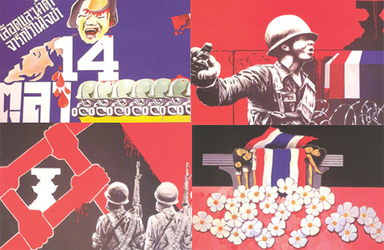

Posters from AFT.’s first exhibition in 1974, held on Ratchadamnern Avenue., Pridi Banomyong Institute, Bangkok.

**Reference and further reading**

Leesuwan, Wiboon. (2005) *Art in Thailand: From Siam to Modern art* (Thai). Bangkok, LadPraw Book Center.

Poshyananda, Apinan. (1992) *Modern Art in Thailand: Nineteenth and Twentieth Centuries.* New York: Oxford University Press.

Tungcharoen, Wiroon. (1991) *Modern Art in Thailand* (Thai). Bangkok, O.S. Printing House.

Yensabai, Amnard. (1997) *Western Art: Its Influence on the Thai Art from 1949 to 1979* (Research). Bangkok, Teacher Training Department, Ministry of Education.